Lab 2 – Microstrip Matching and DC Bias

# Youssef Samwel

# [yo800238@ucf.edu](mailto:yo800238@ucf.edu)

# EEL5439C RF and Microwave Active Circuits

Prof. Dr. Kenle Chen - Section 0012

# 2/15/2024 – 2/22/2024



# **Experiment Objective**

The purpose of this lab is to verify microstrip line matching networks and bias networks at 1 GHz.

# 2.0 Experiment Procedure

The design goal for the following matching circuits is to match a 50 port to a load. In this lab, we tried two different methods, the first is to use classical lumped elements and in the second method we utilize distributed elements (microstrip line).

## 2.2 Lumped Element Matching

By far, lumped element matching is the easiest way to match port impedance to load. To perform this type of matching, the digitized Smith Chart in ADS was used to compute the required LC network values as shown in the accompanying screenshot.

Lumped Element Design using Smith Chart Tool

It is critical to correctly initialize the Smith Chart tool by setting the following parameters:

* Center frequency,
* Load Impedance,
* Source Impedance,
* Lock Source and Load Impedance
* Set Start and Stop Frequency for the Network Response plot.

To extract the component value; simply select the desired lumped element in the network schematic and read the value as shown in the following image.

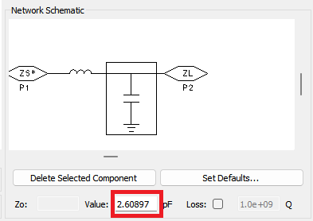

Extracting Computed Value from ADS Smith Chart Tool

The following step is to construct the schematic of the circuit in ADS. This can be done by selecting components from the component’s library in ADS.

Schematic of Lumped Element Matching Circuit

To simulate this schematic in ADS, we must configure the S parameters sweep. For this lab, the manual instructed to perform a sweep from 0.1 GHz to 10 GHz with 0.1 GHz step.

S-Parameter Sweep Configuration

Simulated Response of LC Matching Network

From the simulated response, it is easy to see that the ideal LC Matching Network has perfect matching at 1 GHz. However, this circuit is not practically realizable because of the precision required of the component but more importantly due to the parasitics of the components. Real-world capacitors and inductors will also have some resistance (which will significantly lower the Q-factor) and will also have some inductance (for the capacitor) and some capacitance (for the inductor). These parasitics are due to the physical structure of these lumped elements. In addition, to the ohmic loss experienced by the LC network; there will be design issues caused by Self-Resonant Frequency (SRF). Lumped elements experience SRF because they’re basically an RLC network because all lumped elements have some resistance due to metallic loss and capacitance and inductance due to physical structure.

For microwave applications, it is better to use distributed elements to realize matching networks because of their better Q-factor and reduced parasitics. The downside of transmission lines is that they’re frequency dependent so that a capacitor can become an inductor as frequency is increased and they have larger footprint on circuit and introduce more complexity to the design process.

## 2.4 Distributed Element Matching

### Ideal Distributed Element Matching

Like the lumped element matching, we will also use the Smith Chart Tool to design the transmission line matching circuit, however, in the Smith Chart Tool we will use the transmission line components instead of lumped elements. It is still important to configure the Smith Chart Tool the same way as described in the lumped element section.

Distributed Element Design using Smith Chart Tool

Once the desired values are determined using the Smith Chart Tool, we can construct the schematic in ADS. For Ideal transmission lines, we use the TLIN component from the ADS library to construct the following schematic.

Ideal Transmission Line Matching Schematic

We can use the same S-parameter configuration to simulate this structure.

Simulated Response of TLIN Matching Network

### Microstrip Matching Network

The matching is almost perfect when using ideal TLIN elements, however, it is not possible to physically realize TLIN elements. For this lab, we used microstrip transmission line to realize this matching network.

To incorporate physical microstrip transmission lines in the schematic we must describe the substrate to ADS. In the microwave laboratory we used Roger’s 4003C substrate and configured ADS substrate in the following manner.

Substrate Configuration

To convert the electrical length of the TLIN to physical length we can utilize the LineCalc tool provided by ADS.

It is important to configure the following properties of the LineCalc before any design parameters are computed.

* Center Frequency,
* Relative Permittivity,
* Substrate Height, mil
* Copper Thickness,
* Loss Tangent,
* Characteristic Impedance,

The values used above are the characteristics of Roger’s 4003C substrate they will be different for other materials. After the initial configuration, we can use the electrical length from the TLIN example to compute the physical dimensions of the microstrip transmission line.

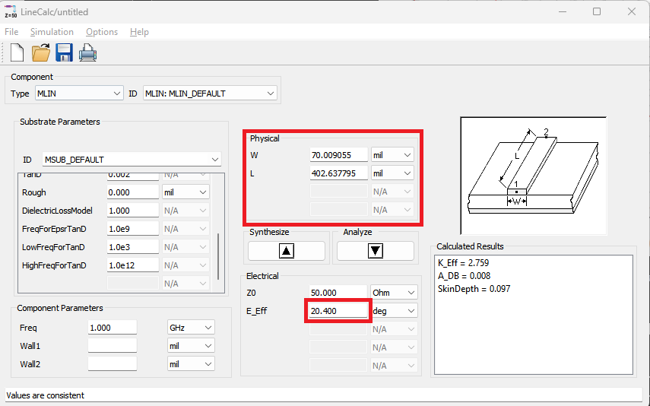

Microstrip Line Design using LineCalc Tool

The illustration above shows how to design the microstrip line using the LineCalc Tool. The input parameters are and the effective electrical length and the output values are the physical width and length of the microstrip line. Using these computed values, we can generate the schematic for the matching network using the microstrip transmission line.

MLIN Matching Schematic

A more accurate schematic is to include a T-junction to connect both MLIN elements because it is not possible to connect both MLIN elements at one point on a physical circuit.

MLIN Matching Schematic with T-Juntion

Simulated Response of MLIN Matching Schematic w/out T-Junction

It is observed that the T-junction causes a shift in the frequency response. We can simulated the physical MLIN matching circuit by creating a layout and using ADS EM solver.

Physical Layout of MLIN Matching Network

The structure was realized using the line draw function in ADS Layout tool. To simulate the structure, it is important to configure the substrate material properties in the ADS workspace.

Substrate Configuration

In EM Setup, set the setup type to EM Simulation/Model and EM Simulator to Momentum Microwave.

Response of Physical MLIN using EM Solver

It is clear that the physical structure has drifted from the schematic performance. To achieve the desired impedemnce matching of we must tune this structure. There are multiple approaches to tune this structure, the first is to tune the schematic of this structure and the second is to use the optimization tool on the layout. The latter method is more accurate because it uses the EM solver to realize the optimization. I chose the EM solver approach and will showcase my method in the following section.

## 2.6 EM Layout Optimization using MoM

The first step in EM layout optimization is the parameterization of the structure. In optimization it is necessary to choose the most important variables to optimize the structure, otherwise, the optimization would require a significant amount of time or may not be possible; therefore, I decided to only optimize the length of the microstrip lines and not the width of the lines. To parameterize this structure, I defined two variables (Series Length) and (Parallel Length). Since the line draw cannot be parameterized, I had to switch from using the line draw function to define this structure to using MLIN and MTEE components in the layout library.

In addition to the structure changes, I had to also change the EM setup to the following configuration.

Revised Layout Structure

|  |  |  |  |  |
| --- | --- | --- | --- | --- |
| Variable | Default Value | Min Value | Max Value | Step |
| SLen | 402 mil | 201 mil | 603 mil | 40.2 mil |
| PLen | 592 mil | 296 mil | 888 mil | 59.2 mil |

Optimization Configuration

Since ADS did not have an expression for impedance, I instead used the following conversion from S11 to impedance.

To optimize both the real and imaginary part of the impedance, I used two goals with equal weights. The first goal was for the real part of the impedance and the second goal was for the imaginary part of the impedance.

Optimization Cockpit

Tuned MLIN Network

## 2.8 DC Bias Design

The DC Bias circuit is used to feed the amplifier with DC source while preventing the RF circuit from “seeing” the DC source. The following design uses a Radial stub because it offers a wider bandwidth. The advantage of using two bias networks is that it will extend the DC bias bandwidth but it will take a larger footprint on the circuit board.

Bias Schematic

Bias Layout

Initial Layout Response

## DC Bias Layout Optimization

The same procedure for optimization was used for this design as the previous design.

Optimization Schematic

Optimized DC Bias

|  |  |
| --- | --- |
| Variable | Value |
| Radial Stub Length | 95 degrees |
| Radial Stub Angle | 1787 mil |
| Open Stub Length | 1700 mil |

# 3.0 Measurements vs Simulation

To view measurement results, I loaded the SnP file into ADS to plot the circuit response. The accompanying screenshot displays the schematic used to plot the measured data.

SnP Measurement Reading

The measured and simulated results are very similar at the center frequency, however, for the Smith Chart, the measurements differ much more at a higher frequency. The DC bias circuit is relatively close to simulation at center frequency, unfortunately, the measured data bandwidth is too small to make additional comments.

# 4.0 Conclusion

In conclusion, this lab explored the design and implementation of microstrip matching networks and DC bias circuits at 1 GHz. Two methods were employed for impedance matching: lumped element matching and distributed element matching using microstrip transmission lines. The lumped element matching showed ideal performance on the Smith Chart, but practical limitations such as component parasitics and self-resonant frequency were acknowledged. In contrast, distributed element matching, especially with microstrip transmission lines, demonstrated improved real-world applicability due to better Q-factor and reduced parasitics, albeit with frequency-dependent characteristics. Overall, the lab provided valuable insights into the process of impedance matching, the challenges in transitioning from ideal to physical components, and the considerations in designing DC bias circuits for RF and microwave applications.